Public Forum
1st Speech

Resolved: The United States Federal Government ought to pay reparations to African Americans.

(Brainstorm your 2 – 3 main reasons)

Pro | Con
- Reason 1  - Reason 2  - Reason 3 | - Reason why not 1  - Reason why not 2  - Reason why not 3

Sample Resolution: The United States government should take steps to curb illegal immigration.

Introduction

Thesis (road map…. What specifically are your 2 – 3 reasons)
First, the threat of terrorism is still very real today and the US should not become lax in its security measures. Second, illegal immigration has a negative influence on our country’s economy. And finally, our current immigration laws are sufficient to protect our country, if enforced.

Contention 1:
Claim: Your statement, the point you are making – no facts (directly from your thesis)The threat of terrorism demands enforcement of current immigration laws.

Warrant: Quotes, evidence, or facts to support your claim

Impact: Why is this important, who does it impact??

Contention 2:
Claim: Illegal immigration has a negative influence on our country’s economy

Warrant:

Impact:

Contention 3:
Claim: Current immigration laws are sufficient to protect our country, if enforced.

Warrant:

Impact

Pro Speech
Resolved: The United States Federal Government ought to pay reparations to African Americans.
Introduction:

Thesis:

Contention 1:

Claim:

Warrant:

Contention 2:

Claim:

Warrant:

Contention 3:

Claim:

Warrant:

Negative Speech
Resolved: The United States Federal Government ought to pay reparations to African Americans.
Introduction:

Thesis:

Contention 1:

Claim:

Warrant:

Contention 2:

Claim:

Warrant:

Contention 3:

Claim:

Warrant:

Research Cards
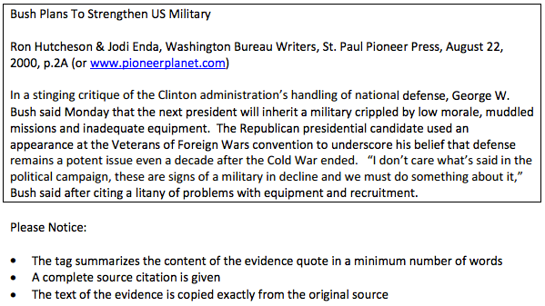

Debate Format

Public Forum Debate Time Format
Speaker A1....................................................................... 4 Minutes
Speaker B1....................................................................... 4 Minutes
Cross-fire (A1&B1).............................................................. 3 Minutes
Speaker A2....................................................................... 4 Minutes
Speaker B2........................................................................ 4 Minutes
Cross-fire (A2&B2)............................................................... 3 Minutes
Summary A1...................................................................... 2 Minutes
Summary B1...................................................................... 2 Minutes
Grand Cross-fire (All)........................................................... 3 Minutes
Final Focus A2....................................................................... 2 Minutes
Final Focus B2....................................................................... 2 Minutes
PREPARATION TIME FOR EACH TEAM....................................... 2 Minutes

Public Forum Debate Time Format
Speaker A1....................................................................... 4 Minutes
Speaker B1....................................................................... 4 Minutes
Cross-fire (A1&B1).............................................................. 3 Minutes
Speaker A2....................................................................... 4 Minutes
Speaker B2........................................................................ 4 Minutes
Cross-fire (A2&B2)............................................................... 3 Minutes
Summary A1...................................................................... 2 Minutes
Summary B1...................................................................... 2 Minutes
Grand Cross-fire (All)........................................................... 3 Minutes
Final Focus A2....................................................................... 2 Minutes
Final Focus B2....................................................................... 2 Minutes
PREPARATION TIME FOR EACH TEAM....................................... 2 Minutes

